数据接口说明 v6.3

1 首页 4
1.1 特卖 4
1.2 最新商品（后台为新货，new） 5
1.3 预上线特卖 5
1.4 指定目录的产品列表（可排序过滤-非优先） 6
1.5 快速搜索结果返回产品列表，并排序 7
1.6 返回指定目录的Filter字段 8
1.7 返回可进行高级搜索的字段 9
1.8 高级搜索结果返回产品列表，并排序 9
2 分类 10
2.1 获取分类列表 10
3 产品 10
3.1 获取指定产品详情（因汇率原因须调整） 10
3.2 获取指定产品图片列表（当前用mag自带，要调整为自写） 11
3.3 获取指定产品自定义选项 12
3.4 获取指定产品自定义属性（非优先，看是否能实现，或者只实现返回指定属性名的内容） 15
4 用户相关 15
4.1 用户登录 15
4.2 获取用户登录状态 15
4.3 用户注册 15
4.4 用户登出 16
4.5 变更密码 16
4.6 用户忘记密码的处理 changepassword 17
4.7 查看用户信息 17
4.8 更新用户信息 17
4.9 用户地址相关 18
5 购物相关 21
5.1 获取购物车数量 21
5.2 获取购物车内容商品内容，相关选项，价格等 21
5.3 加入购物车 22
5.4 更新购物车内容（调整数量，删除等） 22
5.5 取购物车中总金额及优惠券使用情况 23
5.6 在购物车里使用和取消coupon优惠券 24
5.7 购物车客户信息 25
5.8 支付信息 25
5.9 购物车物流信息 26
5.10 购物车完整信息 cart/info 26
5.11 生成订单 27
6 查看订单及物流 27
6.1 查看订单列表orderlist 27
6.2 查看订单详情orderinfo 30
6.3 对指定订单状态增加说明 32
6.4 查看送货单列表 32
6.5 查看送货单详情 33
6.6 查看帐单列表 34
6.7 查看帐单详情 35
7 查看、加入、修改wishlist 37
7.1 查看wishilist 37
7.2 加入wishlist 37
7.3 修改某一条wishlist 38
7.4 删除 38
8 店铺信息 38
8.1 当前网站的店铺和视图列表 38
8.2 当前店铺基础参数 39
8.3 获取指定的CMS block 40
8.4 获取指定的Banner block(转化成ionic格式) 40
9 印章快速查找接口 40
10 门店管理功能与接口 41
10.1 插件管理 41
10.2 输入地址获取附近门店 41
11 资讯管理功能与接口 42
11.1 前端效果 42
11.2 获取资讯目录列表 43
11.3 获取指定目录(所有目录)下的所有文章列表 43
11.4 获取指定文章内容getPost 44
11.5 获取指定文章的评论信息getPostComment 45
11.6 给指定文章添加评论addComment 45
11.7 前端效果（这个是过去用来取附件，停用） 45
11.8 获取具体文章列表及信息（这个是过去用来取附件，停用） 46
12 短信接口 47
12.1 发送验证码 47

注意事项：
- 所有返回数据都是json格式
- 当前 @baseSite= http://58stamp.sunpop.cn/ baseLang=cn
baseUrl=http://58stamp.sunpop.cn/cn

首页

特卖
- 参数说明：
cmd:命令关键字，已默认【daily_sale】
order：排序字段，默认entity_id
desc：排序方式asc/desc，默认desc倒序
page：页码，默认为第1页
limit：每页显示的数据单位，默认显示20件商品
- 默认url:
http://58stamp.sunpop.cn/cn/restconnect/index/index/cmd/daily_sale/order/name/dir/asc/limit/10/page/1
备选url格式(?，&这样的参数传递格式，以下均同)
http://58stamp.sunpop.cn/cn/restconnect/?cmd=daily_sale&page=1&limit=10
- 返回值：
Type | Name | Description
string | entity_id | Product ID
string | type_id | Product type(simple,group…)
string | sku | Product SKU
string | name | Product name
string | regular_price_with_tax | Product price
string | final_price_with_tax | 当前价格，即当产品在特价周期时的特价，不在周期内则为原价
string | special_from_date | Date starting from which the special price is applied to the product
string | special_to_date | Date till which the special price is applied to the product
string | url_key | Relative URL path that can be entered in place of a target path
string | image_url | Image URL

最新商品（后台为新货，new）
- 参数说明：
cmd:命令关键字，这里需要改成【new】
order：排序字段，默认entity_id
desc：排序方式asc/desc，默认desc倒序
page：页码，默认为第1页
limit：每页显示的数据单位，默认显示20件商品
- 默认url:
http://58stamp.sunpop.cn/cn/restconnect/index/index/cmd/new/limit/10/page/1
- 返回值：
Type | Name | Description
string | entity_id | Product ID
string | type_id | Product type(simple,group…)
string | sku | Product SKU
string | name | Product name
string | regular_price_with_tax | Product price
string | final_price_with_tax | 当前价格，即当产品在特价周期时的特价，不在周期内则为原价
string | new_from_date | Date starting from which the special price is applied to the product
string | new_to_date | Date till which the special price is applied to the product
string | url_key | Relative URL path that can be entered in place of a target path
string | image_url | Image URL

预上线特卖
- 参数说明：
cmd:命令关键字，这里需要改成【coming_soon】
order：排序字段，默认entity_id
desc：排序方式asc/desc，默认desc倒序
page：页码，默认为第1页
limit：每页显示的数据单位，默认显示20件商品
- 默认url:
http://58stamp.sunpop.cn/cn/restconnect/index/index/cmd/coming_soon/limit/10/page/1
- 返回值：
Type | Name | Description
string | entity_id | Product ID
string | type_id | Product type(simple,group…)
string | sku | Product SKU
string | name | Product name
string | regular_price_with_tax | Product price
string | final_price_with_tax | 当前价格，即当产品在特价周期时的特价，不在周期内则为原价
string | special_from_date | Date starting from which the special price is applied to the product
string | special_to_date | Date till which the special price is applied to the product
string | url_key | Relative URL path that can be entered in place of a target path
string | image_url | Image URL

指定目录的产品列表（可排序过滤-非优先）
- 参数说明：
cmd:命令关键字，这里需要改成【catelog】
category_id：目录id
order：排序字段，默认entity_id
desc：排序方式asc/desc，默认desc倒序
page：页码，默认为第1页
limit：每页显示的数据单位，默认显示20件商品
筛选： min（最低价格：选填） max（最高价格：选填） dir（排序：选填） order（排序字段：选填） limit（每页数量：选填）
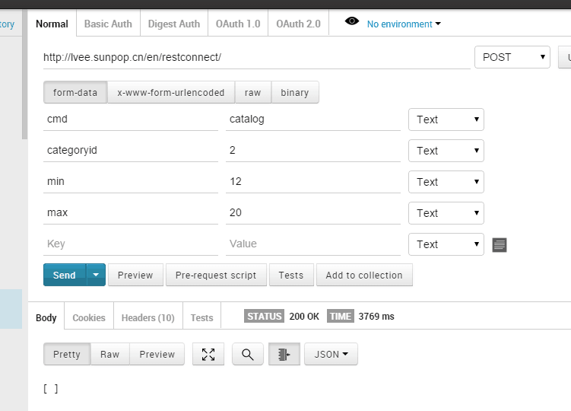
- 默认url:
http://58stamp.sunpop.cn/cn/restconnect/index/index/cmd/catalog/categoryid/3/limit/10/page/1
- 返回值：
Type | Name | Description
string | product_id | Product ID
string | sku | Product SKU
string | name | Product name
ArrayOfString | website_ids | Array of website IDs
string | price | Product price
string | special_price | Product special price
string | special_from_date | Date starting from which the special price is applied to the product
string | special_to_date | Date till which the special price is applied to the product
string | url_key | Relative URL path that can be entered in place of a target path
string | image_url | Image URL

快速搜索结果返回产品列表，并排序
- 参数说明：
cmd:命令关键字，这里需要改成【search】
name：产品名称，可以用空格分隔
其它查询字段：后台设置为可以quick search的字段
order：排序字段，默认entity_id
desc：排序方式asc/desc，默认desc倒序
page：页码，默认为第1页
limit：每页显示的数据单位，默认显示20件商品
- 默认url:
http://58stamp.sunpop.cn/cn/restconnect/search/index/q/2015
- 搜索结果可以参考
http://58stamp.sunpop.cn/cn/catalogsearch/result/?q=2015

- 返回值：
Type | Name | Description
string | product_id | Product ID
string | sku | Product SKU
string | name | Product name
ArrayOfString | website_ids | Array of website IDs
string | price | Product price
string | special_price | Product special price
string | url_key | Relative URL path that can be entered in place of a target path
string | image_url | Image URL

返回指定目录的Filter字段
- 参数说明：
Categoryid：目录的id
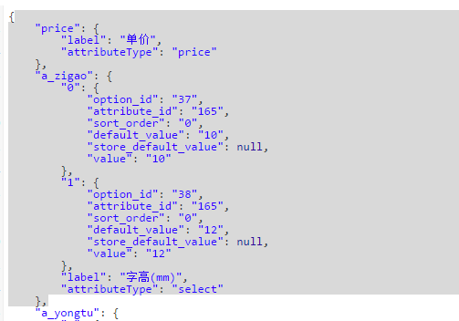
- 默认url:
http://58stamp.sunpop.cn/cn/restconnect/search/getfilter/categoryid/2

返回可进行高级搜索的字段
- 参数说明
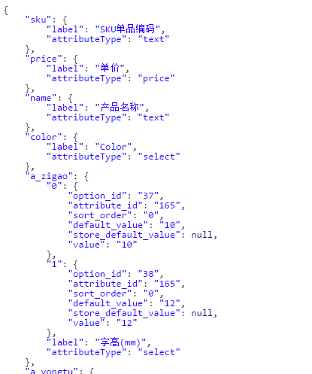
- 默认url:
http://58stamp.sunpop.cn/cn/restconnect/searchadv/getfield

高级搜索结果返回产品列表，并排序
- 参数说明：
name：产品名称，可以用空格分隔
sku：sku产品标识号
其它查询字段：后台设置为可以advance search的字段，即从上面的接口获取的字段
http://58stamp.sunpop.cn/cn/restconnect/searchadv/getfield
order：排序字段，默认entity_id
desc：排序方式asc/desc，默认desc倒序
page：页码，默认为第1页
limit：每页显示的数据单位，默认显示20件商品
- 默认url:
http://58stamp.sunpop.cn/cn/restconnect/searchadv/index
- 举例
http://58stamp.sunpop.cn/cn/restconnect/searchadv/index/a_baozhuang/46/name/新/price/66to100/categoryid/10

分类

获取分类列表
- 参数说明：
cmd:命令关键字，这里需要改成【menu】
注意：一次加载完所有的一级分类。
- 默认url：
http://58stamp.sunpop.cn/cn/restconnect/index/index/cmd/menu
- 返回值：参考
Type | Name | Description
int | category_id | Category ID
int | parent_id | Parent category ID
string | name | Category name
int | is_active | defines whether the category is active
int | position | Category position
int | level | Category level
string | url_key
String | Thumbnail_url
string | Image_url
 | has_children | 是否有子目录
 | product_count | 产品count
 | children | 子目录id列表
 | is_virtual | 该目录是否虚拟产品

产品

获取指定产品详情（因汇率原因须调整）
- 参数说明：
如果在全局中设置了转换汇率，则此接口不用调整
cmd:命令关键字，这里需要改成【product】
id:产品id
- 默认url
http://58stamp.sunpop.cn/cn/restconnect/products/getproductdetail/productid/:id
临时url(Mag自带的)
http://58stamp.sunpop.cn/api/rest/products/75
如：产品id为385，http://58stamp.sunpop.cn/cn/restconnect/products/getproductdetail/productid/75
访问产品页看效果为
http://58stamp.sunpop.cn/cn/index.php/catalog/product/view/id/385
- 返回值：参考返回结果
Type | Name | Description
string | entity_id | Product ID
string | type_id | Product type(simple,group…)
string | sku | Product SKU
string | name | Product name
string | regular_price_with_tax | Product price
string | final_price_with_tax | 当前价格，即当产品在特价周期时的特价，不在周期内则为原价。  返回经过转换的货币值
string | special_from_date | Date starting from which the special price is applied to the product
string | special_to_date | Date till which the special price is applied to the product
string | url_key | Relative URL path that can be entered in place of a target path
string | image_url | Image URL
int | is_in_stock | Is in stock or not
int | has_custom_options | 是否有自定义选项，购物车要用  1为有，0为无  用例：id=385有选项，386无

获取指定产品图片列表（当前用mag自带，要调整为自写）
- 参数说明：
cmd:命令关键字，这里需要改成【product】
id:产品id
- 接口
http://58stamp.sunpop.cn/cn/restconnect/Products/getPicLists
如http://58stamp.sunpop.cn/cn/restconnect/Products/getPicLists/product/76
- 临时url
http://58stamp.sunpop.cn/api/rest/products/:id/images
如：产品id为385，http://58stamp.sunpop.cn/api/rest/products/76/images
- 返回值：参考返回结果

获取指定产品自定义选项
- 参数说明：
id:输入，产品id
返回值可以查看以下页面，需要支持将该页面的自定义选项内容和可选值全部输出，由前端人员将该数据展现
http://58stamp.sunpop.cn/cn/restconnect/products/getcustomeroption/76
- 默认url
http://58stamp.sunpop.cn/cn/restconnect/products/getcustomoption/productid/:id
如：产品id为535，
http://58stamp.sunpop.cn/cn/restconnect/products/getcustomoption/productid/75
- 返回值：
Custom Option[],参考返回结果
- 样例：
简单化的535，复杂的id=385产品,无选项的为533
其后台
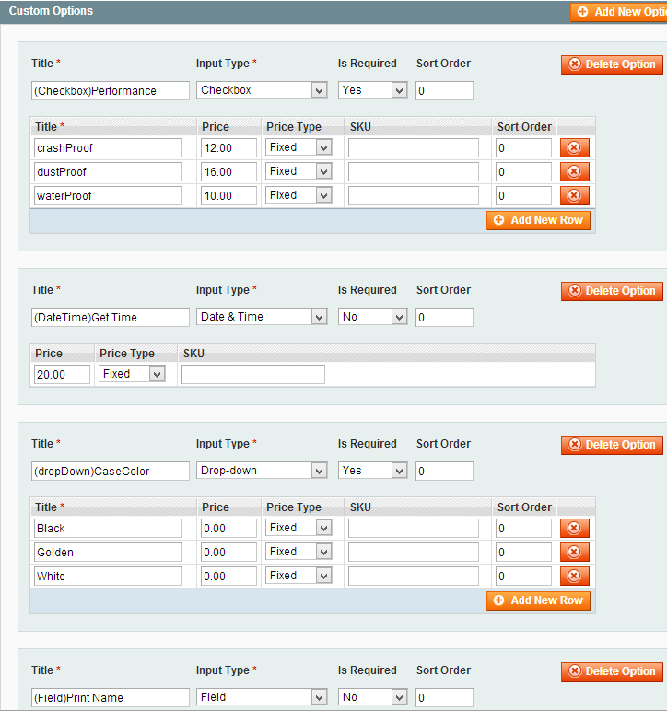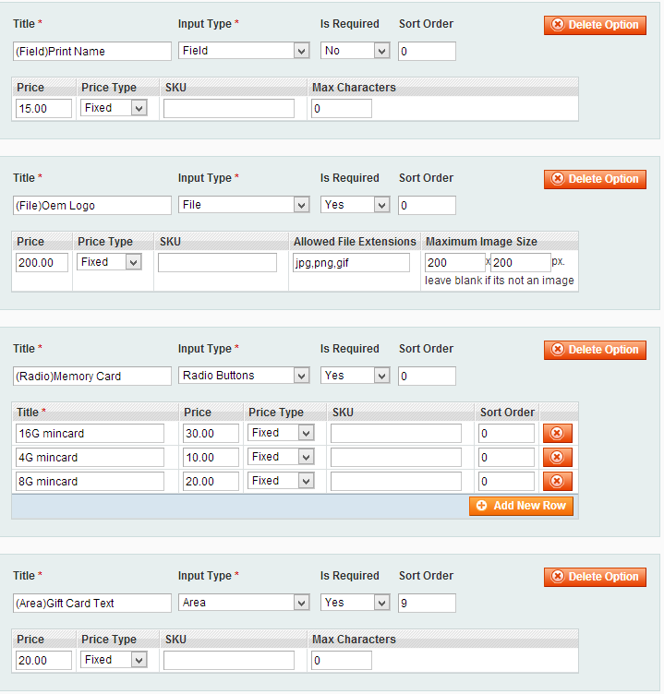
Web前端展现形如（这是目标）：
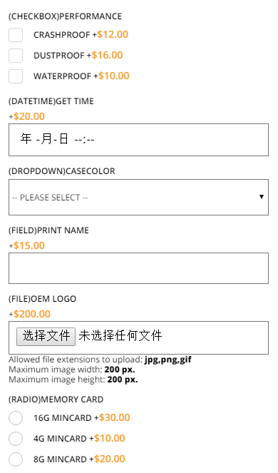 | 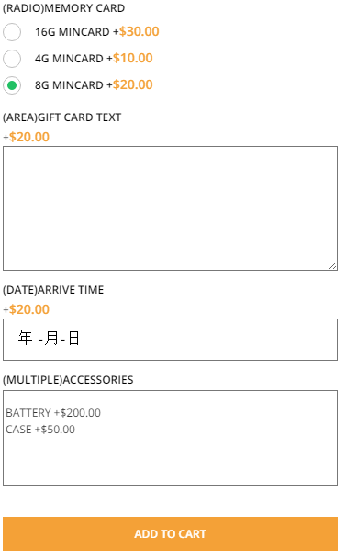
其JSON数据返回形如（这是源数据）
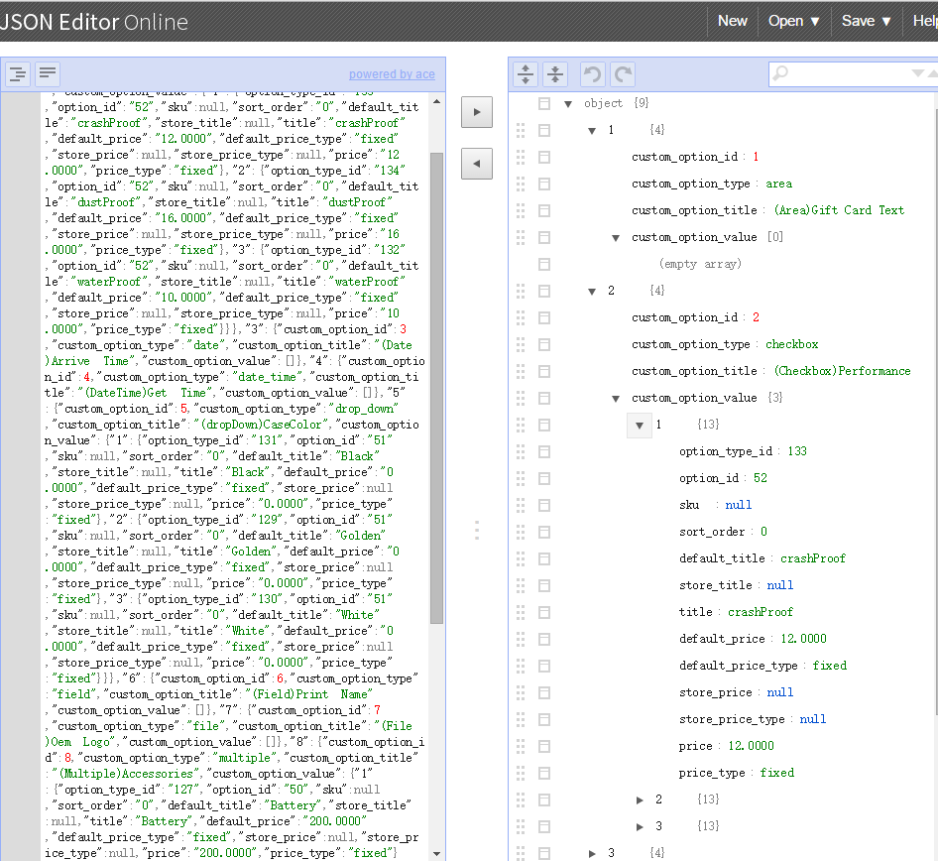

获取指定产品自定义属性（非优先，看是否能实现，或者只实现返回指定属性名的内容）
合并到3.1获取指定商品详情

用户相关

用户登录
- 参数说明：
username: 输入，用户名
password: 输入，密码
- 样例
用户1：300883@qq.com 111111
http://58stamp.sunpop.cn/cn/restconnect/customer/login/username/300883@qq.com/password/111111
- 返回值，用户信息
{"name":"ivan deng","email":"300883@qq.com","avatar":null,"tel":null}

获取用户登录状态
- 参数说明：
如未登录，返回false
如已登录，返回样例
- {"name":"a b","email":"a@qq.com","avatar":"http:\/\/58stamp.sunpop.cn\/media\/customer\/i\/c\/icon_72.png","storeUrl":"http:\/\/58stamp.sunpop.cn\/media\/","tel":"131311131"}
- 样例url:
http://58stamp.sunpop.cn/cn/restconnect/customer/status

用户注册
- 接口url
http://58stamp.sunpop.cn/cn/restconnect/customer/register
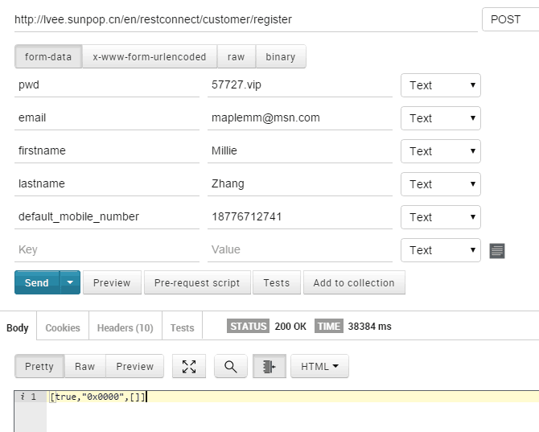
- 参数说明：输入参数在此页面（短信验证在前端完成）
http://58stamp.sunpop.cn/cn/kikuuapp3/register.html 有性别gender
返回是否正常注册成功，错误代码及信息等。

用户登出
发Get请求：baseUrl的 /customer/account/logout
如： http://58stamp.sunpop.cn/cn/customer/account/logout

变更密码
http://58stamp.sunpop.cn/cn/restconnect/customer/forgotpwd
参数：email

用户忘记密码的处理 changepassword
http://58stamp.sunpop.cn/cn/restconnect/customer/chanagepassword/oldpassword/222222/newpassword/111111
参数：oldpassword, newpassword

查看用户信息
只针对已登录用户，已登录用户返回本人信息，未登录的返回false
http://58stamp.sunpop.cn/cn/restconnect/customer/info
- customer.info - Retrieve the customer data // CustomerController.php/infoAction
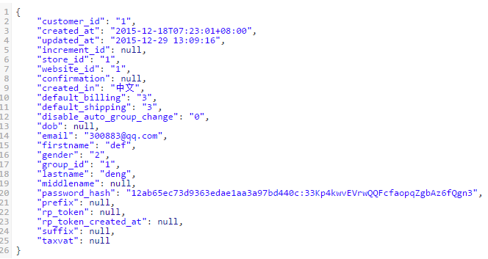

更新用户信息
http://58stamp.sunpop.cn/cn/restconnect/customer/update
Methods: customer.update - Update the customer data // CustomerController.php/updateAction
例如：http://58stamp.sunpop.cn/cn/restconnect/customer/update?gender=1&firstname=abc
或：http://58stamp.sunpop.cn/cn/restconnect/customer/update/gender/2/firstname/def
Arguments:
Type | Name | Description
array | customerData | Array of customerCustomerEntityToCreate
Returns:
Type | Description
boolean | True if the customer is updated
The customerCustomerEntityToCreate content is as follows:
Type | Name | Description
int | customer_id | Customer ID
string | email | Customer email
string | firstname | Customer first name
string | lastname | Customer last name
string | password | Customer password
int | group_id | Group ID
string | prefix | Customer prefix
string | suffix | Customer suffix
string | dob | Customer date of birth
string | taxvat | Customer tax/VAT number
int | gender | Customer gender: 1 - Male, 2 - Female
string | middlename | Customer middle name/initial

用户地址相关
Restconnect/Customer/addressList
- customer_address.list - Retrieve the list of customer addresses // CustomerController.php/addressListAction
- customer_address.create - Create a new address for a customer // CustomerController.php/addressCreateAction
- customer_address.info - Retrieve the specified customer address // CustomerController.php/addressInfoAction
- customer_address.update - Update the customer address // CustomerController.php/addressUpdateAction
- customer_address.delete - Delete the customer address // CustomerController.php/addressDeleteAction
- http://58stamp.sunpop.cn/cn/restconnect/customer/addresslist
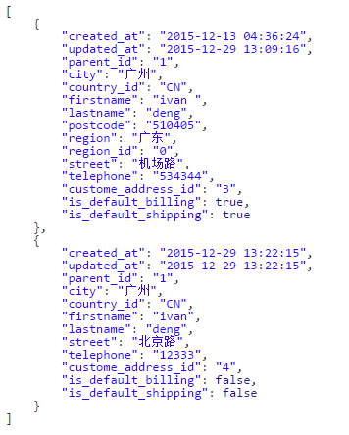
- http://58stamp.sunpop.cn/cn/restconnect/customer/addresscreate
主要参数都要输入
例如：
http://58stamp.sunpop.cn/cn/restconnect/customer/addresscreate/firstname/ivan/lastname/deng/country_id/CN/city/广州/street/北京路/telephone/12333
- http://58stamp.sunpop.cn/cn/restconnect/customer/addressinfo
输入参数：addressid
例如：
http://58stamp.sunpop.cn/cn/restconnect/customer/addressinfo/addressid/3
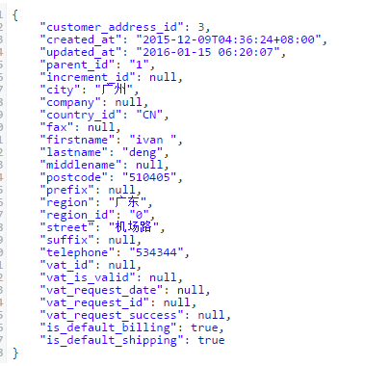
- http://58stamp.sunpop.cn/cn/restconnect/customer/addresscreate
主要参数都要输入
例如：
http://58stamp.sunpop.cn/cn/restconnect/customer/addresscreate/firstname/ivan/lastname/deng/country_id/CN/city/广州/street/北京路/telephone/12333
- http://58stamp.sunpop.cn/cn/restconnect/customer/addressupdate
主要参数都要输入
addressid,firstname,lastname,street
例如：
http://58stamp.sunpop.cn/cn/restconnect/customer/addressupdate/addressid/3/firstname/ivanchange/lastname/deng/country_id/CN/city/广州/street/北京路change/telephone/12333
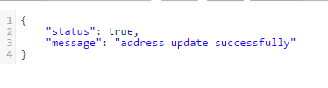
- http://58stamp.sunpop.cn/cn/restconnect/customer/addressdelete
主要参数
addressid
例如：
http://58stamp.sunpop.cn/cn/restconnect/customer/addressdelete/addressid/3

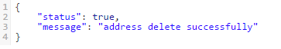

购物相关

获取购物车数量
- 接口：http://58stamp.sunpop.cn/cn/restconnect/Cart/getQty
- 返回：{"items_qty": "1"}

获取购物车内容商品内容，相关选项，价格等
- 接口：http://58stamp.sunpop.cn/cn/restconnect/Cart/getCartInfo
- 返回，见下例
{"is_virtual":false,"cart_items":[{"cart_item_id":"206","currency":"TZS","entity_type":"simple","item_id":"27","item_title":"Women's blouse","qty":3,"thumbnail_pic_url":"http:\/\/58stamp.sunpop.cn\/media\/catalog\/product\/cache\/1\/thumbnail\/75x\/9df78eab33525d08d6e5fb8d27136e95\/b\/l\/blouse_1.jpg","custom_option":[{"label":"color","value":"black","print_value":"black","option_id":"12","option_type":"drop_down","option_value":"24","custom_view":false},{"label":"size","value":"M","print_value":"M","option_id":"11","option_type":"drop_down","option_value":"23","custom_view":false}],"item_price":96740},{"cart_item_id":"207","currency":"TZS","entity_type":"simple","item_id":"45","item_title":"Iphone5s slash ","qty":1,"thumbnail_pic_url":"http:\/\/58stamp.sunpop.cn\/media\/catalog\/product\/cache\/1\/thumbnail\/75x\/9df78eab33525d08d6e5fb8d27136e95\/_\/1\/_1_2_2.jpg","custom_option":[],"item_price":7739.2},{"cart_item_id":"208","currency":"TZS","entity_type":"simple","item_id":"67","item_title":"Light blue jeans 2015 New Fashion","qty":1,"thumbnail_pic_url":"http:\/\/58stamp.sunpop.cn\/media\/catalog\/product\/cache\/1\/thumbnail\/75x\/9df78eab33525d08d6e5fb8d27136e95\/1\/1\/116_-1.png","custom_option":[],"item_price":92870.4}],"messages":null,"cart_items_count":5,"payment_methods":[],"allow_guest_checkout":false}
- 购物车总数：cart_items_count，购物车中单项的id：cart_item_id

加入购物车
- 参数说明（可根据实际调整）：
一个json数组
entity_id: 输入，商品的id
qty: 输入，商品数量
options[]：输入，自定义选项数组变量名
optionvalue[]：输入，自定义选项数组变量值
- 默认url
http://58stamp.sunpop.cn/cn/restconnect/cart/add/
简单的包含qty，复杂的包含各种选项
- 发送参数的例子，和mag的购物form发送内容一致，或用json封装
如：?product=535&related_product=&options%5B67%5D=abc&options%5B62%5D=148&options%5B63%5D%5B%5D=150&options%5B60%5D=143&options%5B61%5D%5B%5D=144&qty=1
空选项
http://58stamp.sunpop.cn/cn/restconnect/cart/add/?product=533&qty=1
- json例子
{'name':'xxxxxx','product':'535','qty':'1','option':['62':'146','60':'143']}
- 返回值，true,false，购物车当前总条目数量

更新购物车内容（调整数量，删除等）
更新购物车指定项为指定数量，参数 cart_item_id，qty，qty设置为0会报错，前端最好让其不设置为0，或设置为0时调用remove事件。
http://58stamp.sunpop.cn/en/restconnect/Cart/update
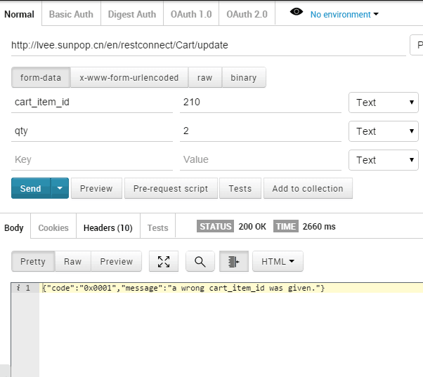

删除，参数cart_item_id，删除前要出提示信息问客户确认删除
http://58stamp.sunpop.cn/en/restconnect/Cart/remove

取购物车中总金额及优惠券使用情况
http://58stamp.sunpop.cn/en/restconnect/Cart/getTotal
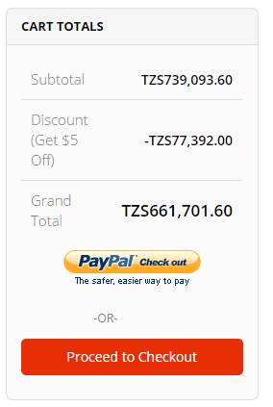

在购物车里使用和取消coupon优惠券
http://58stamp.sunpop.cn/cn/restconnect/Cart/postCoupon
参数1、 coupon_code：优惠券码 2、remove ：为1时表示移除优惠券，为0时表示使用优惠券，默认为0

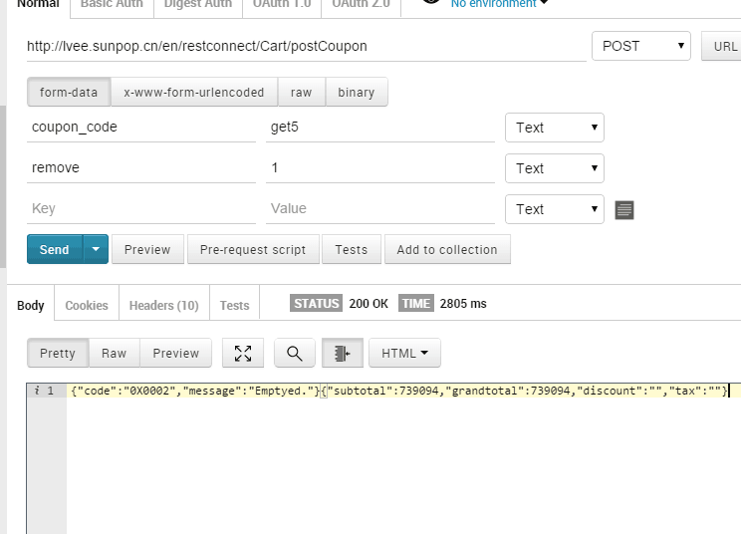

购物车客户信息
Allows you to add customer information and addresses into a shopping cart.
Resource Name: cart_customer
Methods:
- cart_customer.set - Add customer information into a shopping cart //CartController.php/customerSetAction
- cart_customer.addresses - Set the customer addresses (shipping and billing) into a shopping cart ///CartController.php/customerAddressesAction

支付信息
Allows you to retrieve and set payment methods for a shopping cart.
Resource Name: cart_payment
Methods:
- cart_payment.method - Set a payment method for a shopping cart ///CartController.php/paymentMethodAction

- cart_payment.list - Get the list of available payment methods for a shopping cart
例如：http://58stamp.sunpop.cn/cn/restconnect/Cart/paymentlist
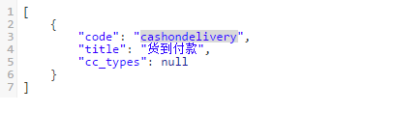
/CartController.php/shippingListAction

购物车物流信息
Allows you to retrieve and set shipping methods for a shopping cart.
Resource Name: cart_shipping
Methods:
- cart_shipping.method - Set a shipping method for a shopping cart /CartController.php/shippingMethodAction
- cart_shipping.list - Retrieve the list of available shipping methods for a shopping cart /CartController.php/shippingListAction

购物车完整信息 cart/info
cart.info - Get full information about the current shopping cart
Arguments:
Type | Name | Description
int | quoteId | Shopping cart ID (quote ID)
string | store | Store view ID or code (optional)
http://58stamp.sunpop.cn/cn/restconnect/Cart/cartInfo

生成订单
Allows you to manage shopping carts.
Resource Name: cart
Methods:
- cart.order - Create an order from a shopping cart /Cart/order
- cart.license - Get website license agreement /Cart/license

查看订单及物流
- sales_order.list - Retrieve the list of orders using filters /order/list
- sales_order.info - Retrieve the order information /order/info
- sales_order.addComment - Add a comment to an order /order/addcomment
- sales_order_shipment.list - Retrieve a list of shipments using filters /order/shipmentlist
- sales_order_shipment.info - Retrieve information about the shipment /order/shipmentinfo
- sales_order_invoice.list - Retrieve a list of invoices using filters
- sales_order_invoice.info - Retrieve information about the invoice

查看订单列表orderlist
相关参数
- sales_order.list - Retrieve the list of orders using filters /order/list
参考
http://58stamp.sunpop.cn/cn/restconnect/order/list
订单id是"increment_id"
过滤参数主要是state状态代码，status状态显示内容，一般使用state。
1. 新订单state : new status : pending
2. 配送后state : processing status : processing
3. 收款后state : processing status : processing
4. 订单完成state : complete status : complete
5. 订单取消state : canceled status : canceled
6. 订单关闭state : closed status : closed
7. 订单挂起state : holded status : holded
其它筛选参数string increment_id ,string created_at ,string order_currency_code ,string order_id,string state(Order state),string grand_total(Grand total amount invoiced) 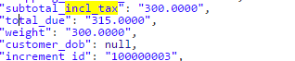
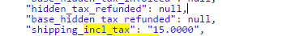
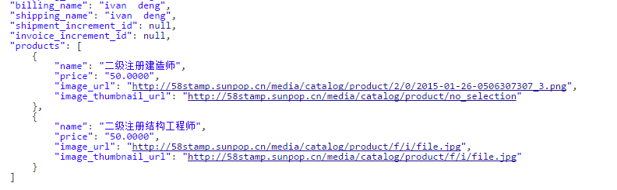
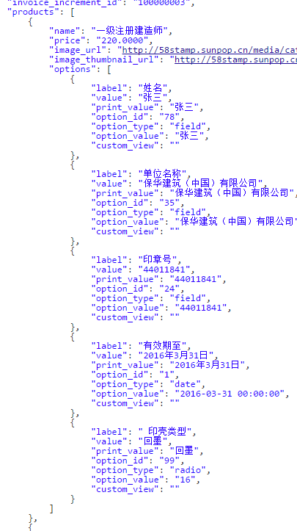
- 返回值：参考
Type | Name | Description
string | state | 状态码
string | increment_id | 订单id，生成订单会生成
string | shipment_increment_id | 运单id，发货后会生成
string | invoice_increment_id | 帐单id，收款后会有生成
string | shipping_description | 运输类型描述
string | subtotal_incl_tax | 产品总价
string | shipping_incl_tax | 运输价格
string | total_due | 总价
array | Products->option | 订单内产品信息  Name,price,image_url  前端图用image_thumbnail_url  产品选项，前端只用展现value,value…这样的形式，如  “张三，保华建筑…”

查看订单详情orderinfo
相关参数
- sales_order.info - Retrieve the order information /order/info
参考
http://58stamp.sunpop.cn/cn/restconnect/order/info/increment_id/100000003
订单id是"increment_id"
如果有运输，对应的运单id是 "shipment_id"
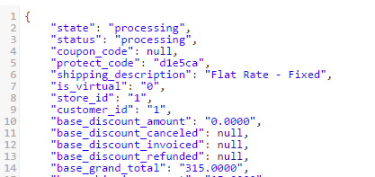
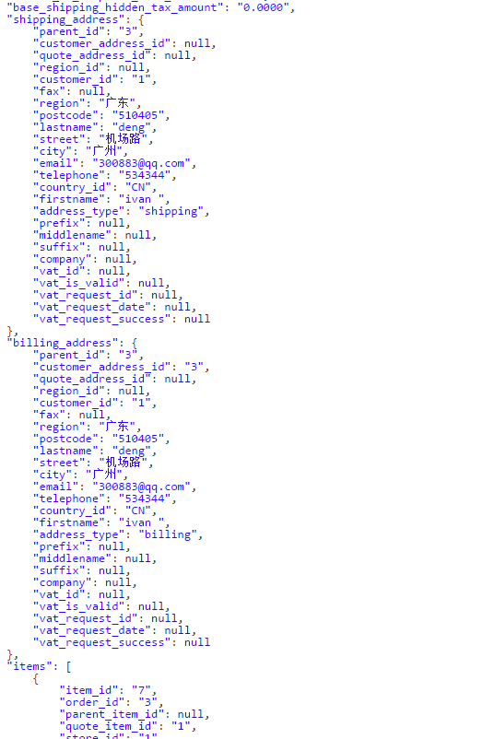
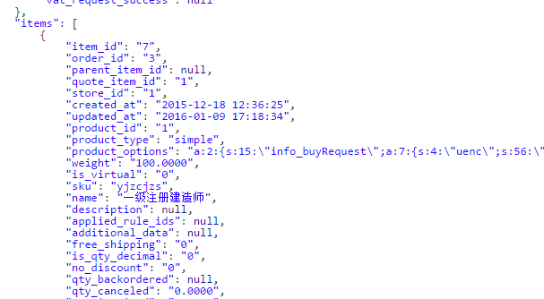

对指定订单状态增加说明
相关参数
- sales_order.addComment - Add a comment to an order /order/addcomment
参考
http://58stamp.sunpop.cn/cn/restconnect/order/addComment/increment_id/100000003/status/processing/comment/这是一个测试
http://58stamp.sunpop.cn/cn/restconnect/order/addComment/increment_id/100000003/status/holded/comment/这是一个挂起状态测试
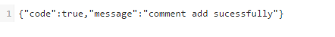

查看送货单列表
系统的处理是每一张订单，如果进行送货，会生成一张送货单，有单独的送货单号
相关参数
- sales_order_shipment.list - Retrieve a list of shipments using filters /order/shipmentlist
参考
http://58stamp.sunpop.cn/cn/restconnect/order/shipmentlist
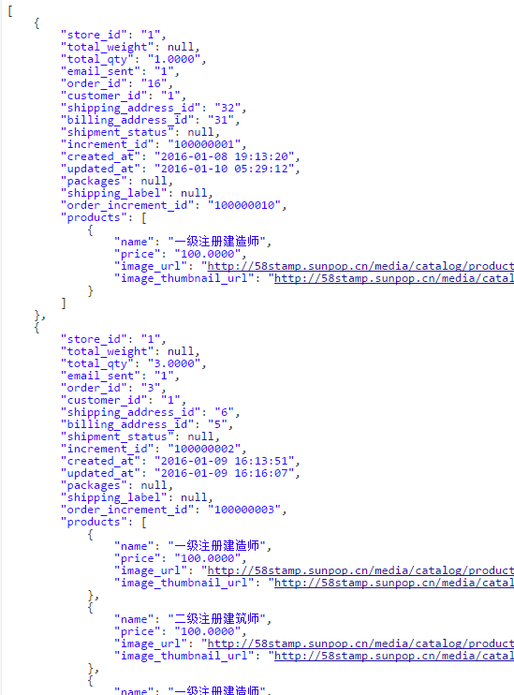
Type | Name | Description
string | shipping_address_id | 送货地址id
string | increment_id | 运单id，发货后会生成
string | order_increment_id | 对应的订单id

查看送货单详情
系统的处理是每一张订单，如果进行送货，会生成一张送货单，有单独的送货单号
相关参数
- sales_order_shipment.info - Retrieve information about the shipment /order/shipmentinfo
参考
http://58stamp.sunpop.cn/cn/restconnect/order/shipmentinfo/shipment_increment_id/100000001
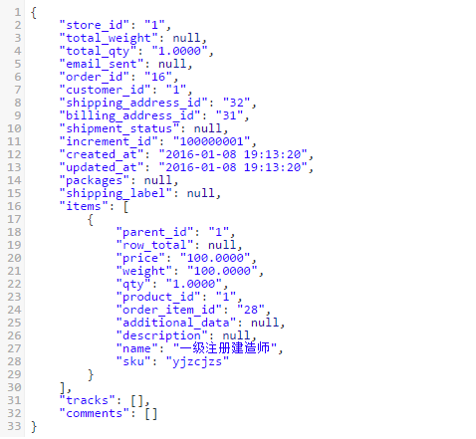

查看帐单列表
系统的处理是每一张订单，如果进行送货，会生成一张送货单，有单独的送货单号
相关参数
- sales_order_invoice.list - Retrieve a list of invoices using filters参考
http://58stamp.sunpop.cn/cn/restconnect/order/invoicelist
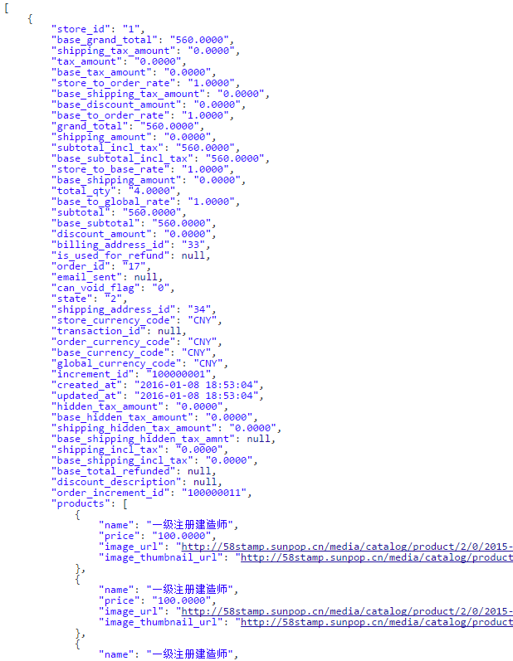
Type | Name | Description
string | increment_id | 帐单id，发货后会生成
string | order_increment_id | 对应的订单id

查看帐单详情
系统的处理是每一张订单，如果进行收款，会生成一张收款单，有单独的收款单号
相关参数
- sales_order_invoice.info - Retrieve information about the invoice
参考
http://58stamp.sunpop.cn/cn/restconnect/order/invoiceinfo/invoice_increment_id /100000001
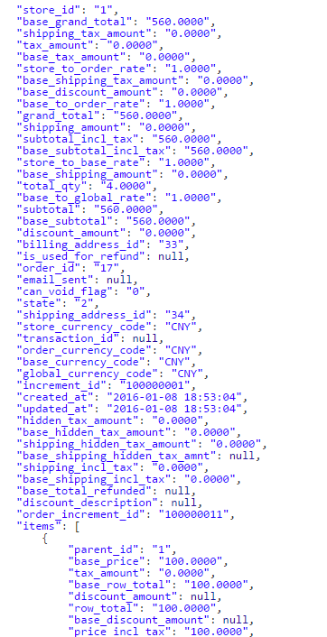

查看、加入、修改wishlist

查看wishilist
http://58stamp.sunpop.cn/cn/restconnect/Wishlist/getWishlist
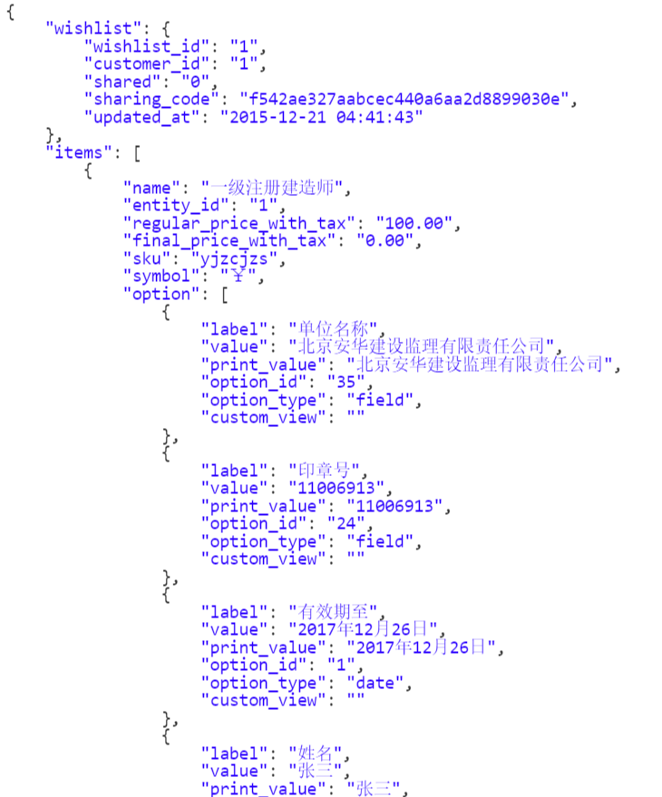

加入wishlist
当前只要用户下单，即可自动将产品和相关选项加入到wishlist
http://58stamp.sunpop.cn/cn/restconnect/Wishlist/addToWishlist
输入参数-产品id：product
增加产品的选项参数。

addToWishlist 参数是数组形式类似 product=1&options[option_id]=姓名&options[option_id]=注册区域&options[option_id]=证书&options[option_id]=类型&options[option_id]=单位。
option_id 是当前custom option对应的option_id，product是产品id,使用http_build_query()构造URL字符串

修改某一条wishlist
updateItemOptionsAction 参数product=1&id=109&options[7]=注册区域109 product是产品对应id, id是当前item对应id,options是custom option对应信息 使用http_build_query()构造URL字符串

删除
remove 参数item 参数item是当前item对应id

店铺信息

当前网站的店铺和视图列表
- 查看
http://58stamp.sunpop.cn/cn/restconnect/store/websiteinfo
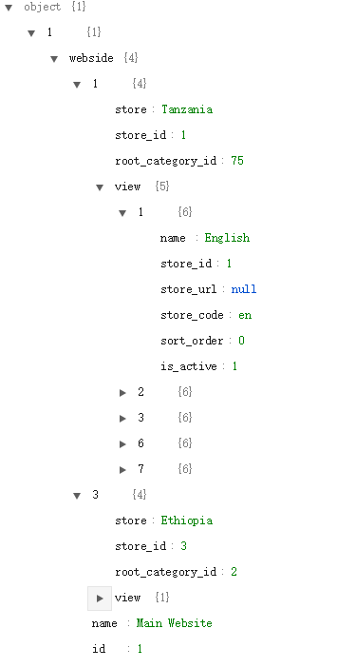

当前店铺基础参数
- 查看
http://58stamp.sunpop.cn/cn/restconnect/store/storeinfo
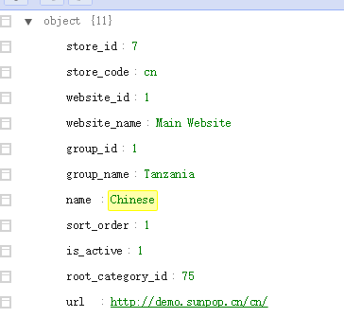

获取指定的CMS block
http://58stamp.sunpop.cn/cn/restconnect/index/getstaticblock?block=app_home_banner1
参数：block=[xxx]

获取指定的Banner block(转化成ionic格式)
这个接口把magento的静态html中的<p>变成 <ion-slide>
http://58stamp.sunpop.cn/cn/restconnect/index/getbannerblock?block=app_home_banner1
参数：block=[xxx]

印章快速查找接口
http://58stamp.sunpop.cn/cn/stampcustomer/index/ajaxdata
输入参数
字段名 | 类型/长度 | 说明
a_state | C30 | 注册区域
a_name | C30 | 姓名
a_company | C100 | 公司
a_certtype | C30 | 专业类型
a_certsn | C30 | 注册证书号
a_stampsn | C30 | 印章号
a_expdate | date | 有效期至
例如：http://58stamp.sunpop.cn/cn/stampcustomer/index/ajaxdata/a_name/张三/a_state/北京

门店管理功能与接口

插件管理
- 前端使用（北上广各一店测试数据）
http://58stamp.sunpop.cn/cn/storelocator

输入地址获取附近门店
- 参数说明：
lng：经度
lat：纬度
radius：查询半径（公里），默认200公里
通过百度接口获取指定地址的经纬度（js）
http://developer.baidu.com/map/jsdemo.htm#i7_1
百度sk: Ggg84DrtSDEWnG2XNVLxUG1GWIDEeshA
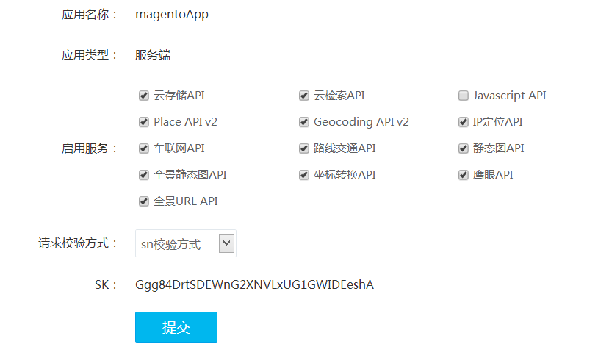
- 默认url:
http://58stamp.sunpop.cn/cn/storelocator/index/city/
样例：
http://58stamp.sunpop.cn/cn/storelocator/index/city/lat/23.191411/lng/113.266943/radius/200

资讯管理功能与接口
最新的要配合Porto模板使用。
BlogController.php 写了5个函数
getCategoryListAction() 获取blog目录列表
getCategoryPostListAction 获取blog指定目录(所有目录)下的所有文章列表
getPostAction 获取指定文章内容
getPostCommentAction 获取指定文章的评论信息
addCommentAction 给指定文章添加评论

前端效果
http://58stamp.sunpop.cn/cn/blog

获取资讯目录列表
http://58stamp.sunpop.cn/cn/restconnect/blog/getCategoryList
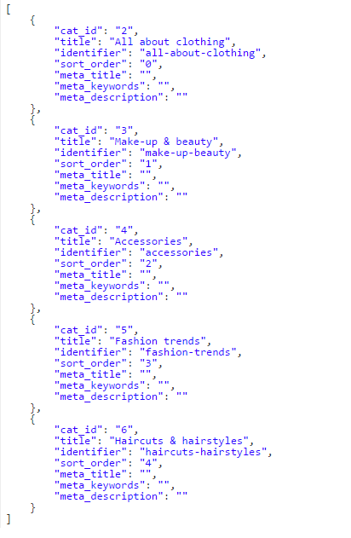

获取指定目录(所有目录)下的所有文章列表
http://58stamp.sunpop.cn/cn/restconnect/blog/getCategoryPostList
http://58stamp.sunpop.cn/cn/restconnect/blog/getCategoryPostList/category_id/5
目录参数： category_id
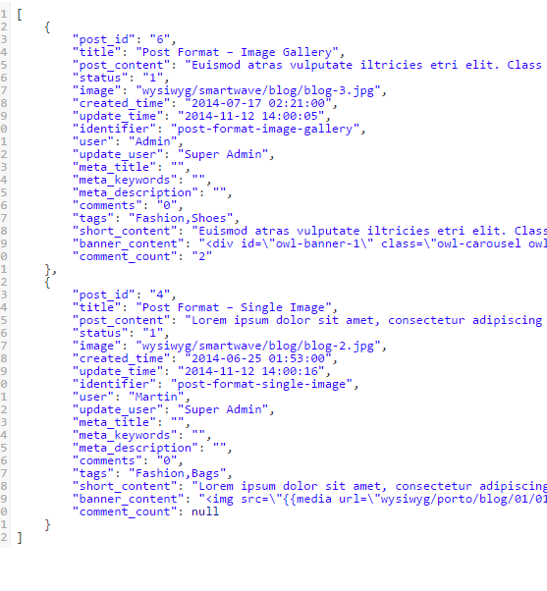

获取指定文章内容getPost
http://58stamp.sunpop.cn/cn/restconnect/blog/getpost/post_id/6
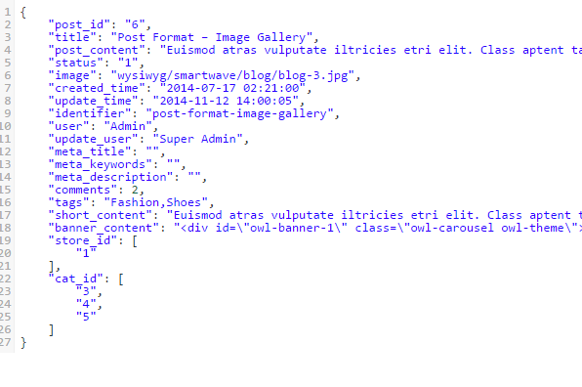

获取指定文章的评论信息getPostComment
http://58stamp.sunpop.cn/cn/restconnect/blog/getPostComment/post_id/6
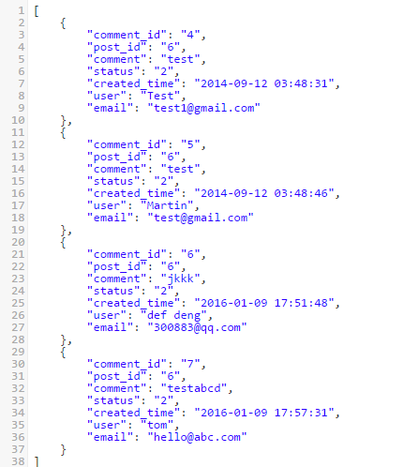

给指定文章添加评论addComment
http://58stamp.sunpop.cn/cn/restconnect/blog/addComment/post_id/6/comment/testabcd/user/tom/email/hello@abc.com
要输入post_id,comment,user,email这些参数值，在app上都可以取到当前用户的相关值
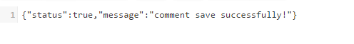

前端效果（这个是过去用来取附件，停用）
http://shiny.sunpop.cn/en/news
获取新闻目录（这个是过去用来取附件，停用）
http://shiny.sunpop.cn/cn/clnews/api/category
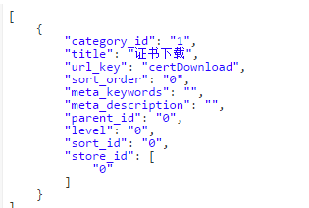

获取具体文章列表及信息（这个是过去用来取附件，停用）
http://shiny.sunpop.cn/cn/clnews/api/article
可以加目录过滤，如：
http://shiny.sunpop.cn/cn/clnews/api/article/categoryid/1
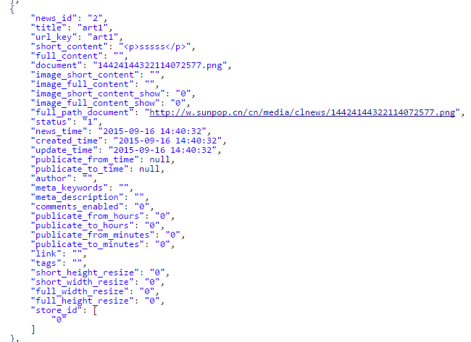

短信接口
供应商：http://www.yuntongxun.com

发送验证码
接口地址：http://58stamp.sunpop.cn/smsapi/SendTemplateSMS.php
参数：以get方式发送
Mobile:手机号
Validation:验证码
Timeout:多少分钟内输入有效
Template:模板号，暂时用 43210
